

**National University**



of Computer

and

Emerging Sciences

Chiniot

-

Faisalabad Campus



**EE1005 – Digital Logic Design**

**Quiz# 3**

**Instructor:** Muhammad Adeel Tahir **Section:** SE-2A **Time:** 20 Minutes

**Name: _____________________________**

**Roll No: ____________________________ Total: 10 marks**

***Note:*** *Use the back side of the page if needed. Make sure the handwriting is neat and clean while drawing the circuit, quiz will be marked as 0 if attempted in a writing that is not readable at all.*

**Q1: Simplify the following function, and implement them with two-level NAND gate circuits:**

**Solution:**

**Marking Criteria:**

Expression and correct k map: 5 marks

Circuit diagram: 5 marks

**NOTE: Incase the quiz is not readable, and the handwriting and cutting is too much, 50% deduction may apply. Do not submit such cases for queries later. Such quizzes will have BH/C written on the top of their quiz meaning “bad handwriting/cutting” in bubble.**

The map of the given function:

is as shown below in (a). This function can be simplified as shown below in (b). The simplified function is

This function can be expressed as

Therefore, we can implement the function *F* using two-level NAND gate circuit as shown below in (c).

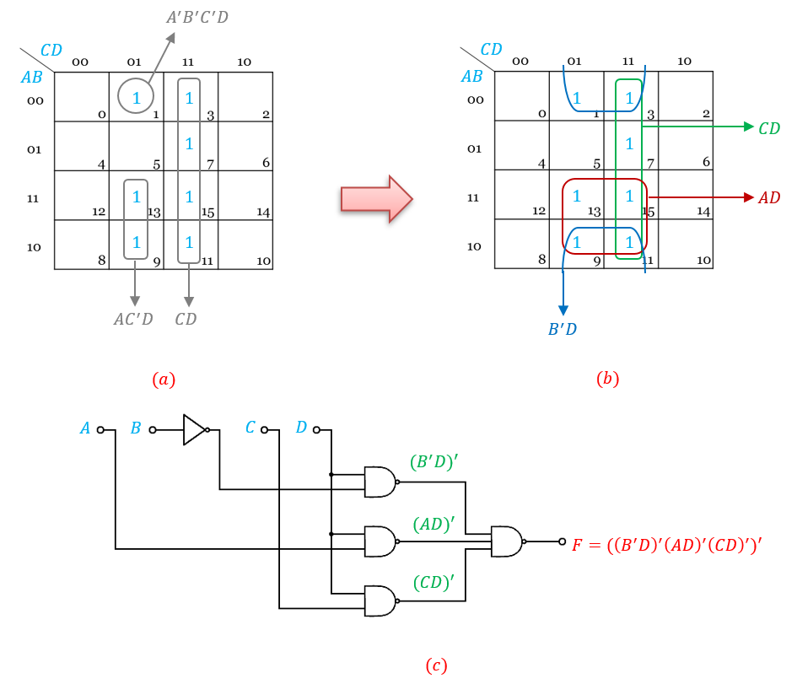

**Q2: Simplify the Boolean function F(w , x , y , z) = Σ (4,5,6,7,12) with don't care function d(w ,x ,y ,z) = Σ (0,8,13). Also draw the circuit diagram.**

**Solution:**

**Marking Criteria:**

Binary checking. Zero if not any value is wrong including expression/kmap.

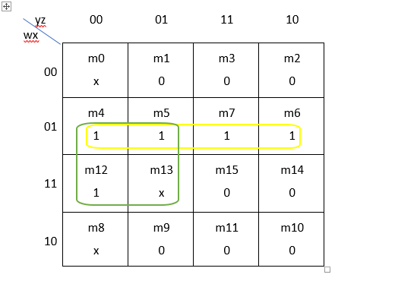

**Q3: Implement the following using 2 Input NOR gates only: *F* =∑(0,3,12,15)**

**Solution:**

**Marking Criteria:**

Expression and correct k map: 4 marks

Circuit diagram: 4 marks

**First, the 1's of**

**K-map plotted as shown below in (a). Then, from the 0's, we get**

The simplified function in the minimum-product-of-sums form is

o implement the function *F* using two-level NOR gate circuit, we reformulate the function as follows:

